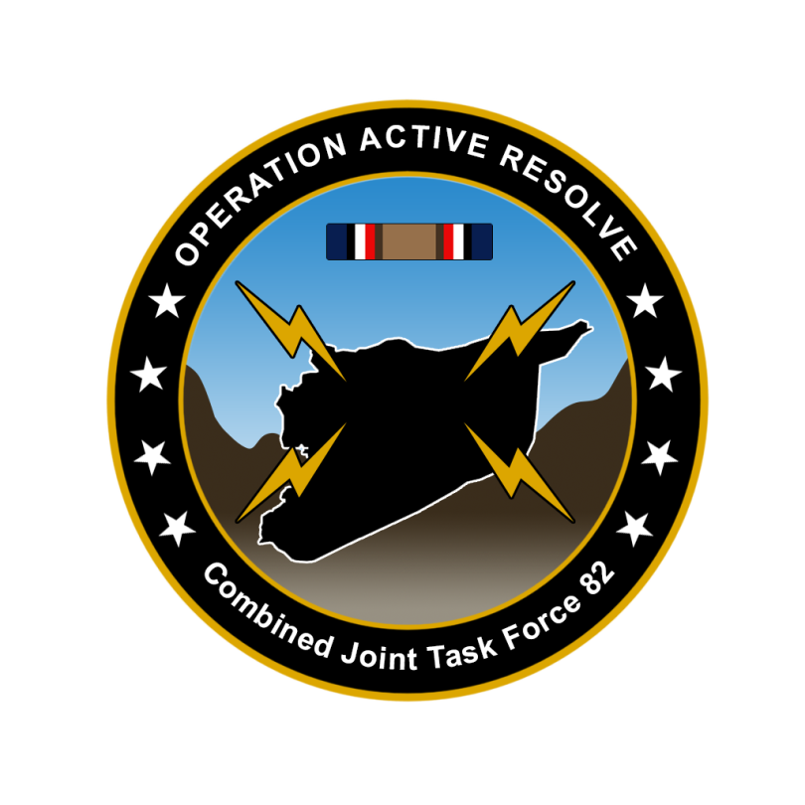

CJTF-82 DIRECTION AND GUIDANCE

D9

This document covers the friendly situation from D7 and provides CJTF-82 guidance to the entire force for D9.

**Reference CombatFlite**: <https://github.com/132nd-vWing/OPAR-Brief/raw/master/COMBATFLITE/OPAR%20Friendly%20situation.cf>

# SITUATION

## General situation

September 1st 2011 (D1) JFACC initiated airstrikes against Syrian forces while LCC started preparing its offensive. During D2 JFACC have continued engagements toward Syrian forces in Syria and in the occupied territory. Turkish local forces have been heavily engaged against Syrian forces IVO the Ataturk Dam, and despite support by CAS assets the area have fallen to Syrian hands. During D3 Syrian air assets have been reduced with efforts on Tabqa airbase. During D4 Syrian air assets was reduced through an attack at Hama airfield. JFACC supported LCC with several sorties to prepare for ground assault planned to start D5. During D5, JFACC focused on the effort of shaping the battlefield for LCC to set conditions for the ground assault that started on D6. During D6, ground forces were able to seize Gazintiep and have now taken control of the airfield.

On D6 the Turkish 33rd Brigade reported heavy fighting in along the FLOT SOUTH of Sanliurfa.

D7 saw continued fighting and further success by LCC increasing the area around Gazintiep. During D8, LCC met hard resistance to on its way to crossing the Euphrates. At D8 JFACC successfully targeted SCC East at Tabqa and conducted a strike at The Syrian Air Defense Academy.

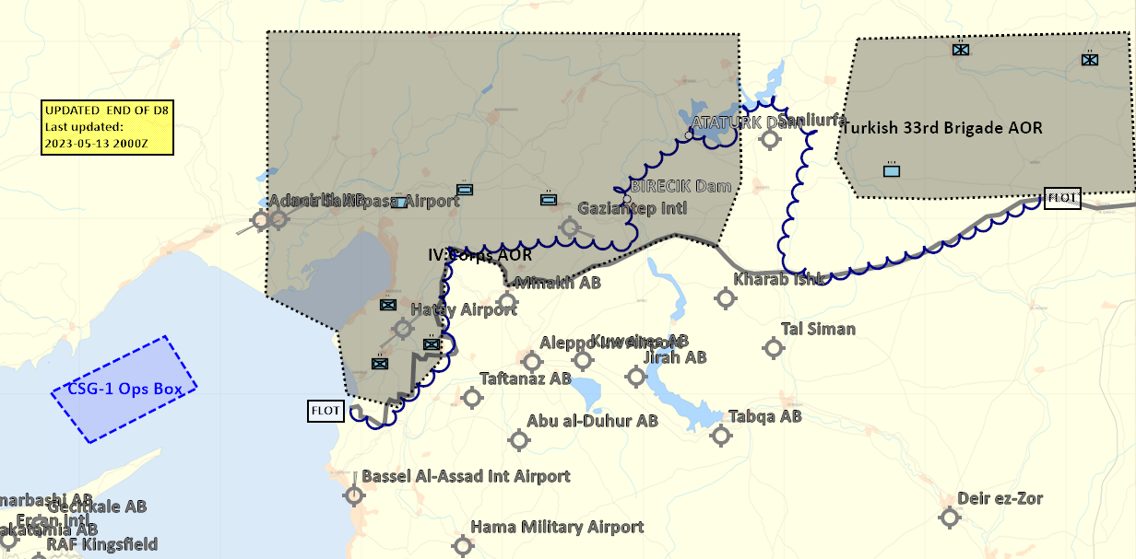

## Friendly situation

### Land Component Command (LCC)

#### IV Corps

55th Mechanized Division has secured HATAY and have moved forward battalions to screening positions along the FLOT.

56th Armor Division has its forward elements at the southern outskirt of Gaziantep and are moving according to LCC plan. Gaziantep Airfield is now fully under allied control and shipments of fuel and ordnance have started to arrive. The airfield can now be used for AH-64s and A-10s.

Local FLOT in Gazientep area

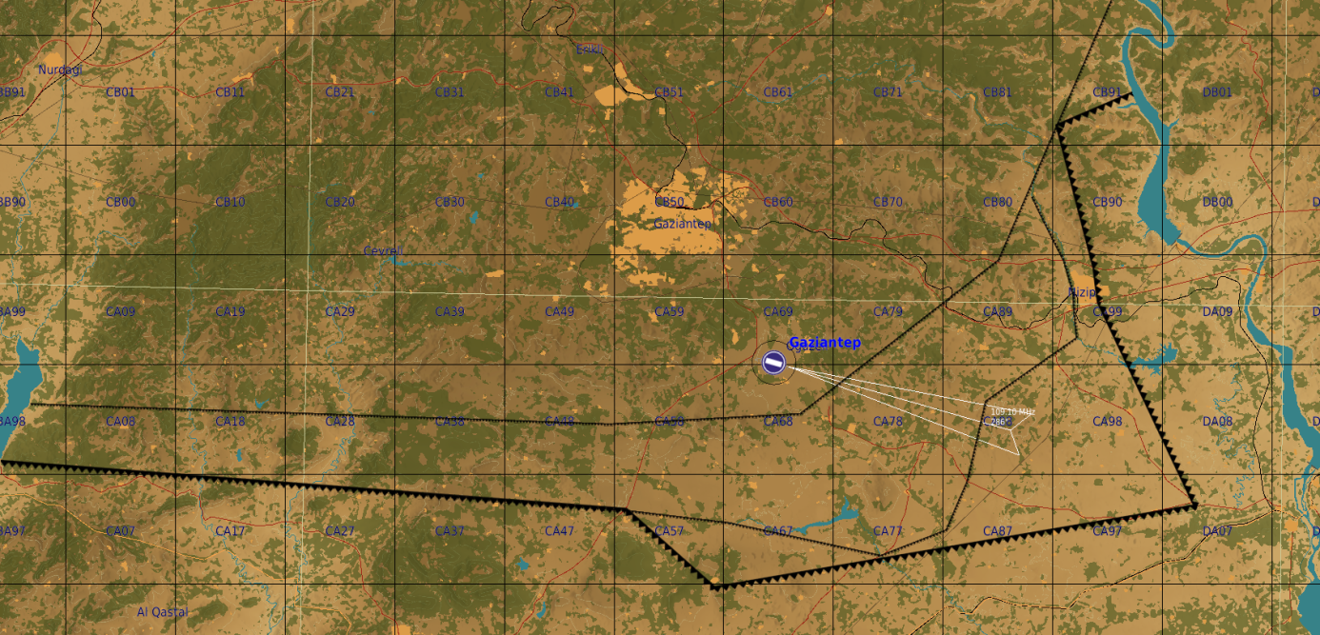

#### Turkish local forces

* The Turkish 33rd Brigade has been neutralized and Syrian forces have now taken control of Sanliurfa.

### Maritime Component Command (MCC)

* CSG-1 continues to support the mission from CSG-1 operations box.
* SAG 1 have been directed to head west in the Mediterranean due to sinking of a ship carrying ordnance for JFACC.

### Joint Force Air Component Command (JFACC)

* IAW JFACC JAOP.

### Special Operations Component Command (SOCC)

* SOF teams are standing by to support with reconnaissance as required and requested by JFACC/VIS.
  + SOF team inserted to observe and report at: 922nd SCUD regiment Base (SYTGT003)
  + SOF team inserted to observe and report at: South Aleppo Rocket Fuel factory (SYTGT137)
  + SOF team inserted to observe and report at: Tartus (SYTGT056)
* SOF teams are also on standby to conduct counter terrorism missions and counter insurgency operations.

# Reported Battle Damage Assessment D8

## IV Corps Northern Sector

* NSTR

## Turkish ground forces.

* NSTR

# Logistical situation

* JFACC need to provide a request for munitions needed for phase 2. Submit together with CONOP for phase 2 NLT end of D9.

# Direction and Guidance

## LCC:

* Continue operation to free Gazientiep and free rest of Turkey
* Priority of effort is on 56th Armored Division attack at Gazientep.
* Prepare plan for phase 2
  + Submit CONOP (Concept of Operations) to CJTF HQ for approval
  + CONOP submitted ASAP to JFC (coordinated with JFACC).

## MCC:

* BPT move CSG-1 operations box based on JFACC needs.
* Use SAG-1 to protect shipping in the western Mediterranean.

## JFACC:

* Apportionment[1]
  + DCA: 5%
  + OCA: 40%
  + Strike/Air Interdiction: 25%
  + Support LCC: 25%
    - AR:5%
    - CAS: 20%
  + Support MCC:
    - ASUW/NTISR: 5%
* Priority of effort is on establishing Air Superiority in support of LCC and set conditions for own operations.
* Start shaping for phase 2 in the operation (Create permissive environment).
* Start strike operations in Syria as applicable.
* Continue support to LCC in effort to free Turkey.
  + RESTRICTION: Reduce/limit AR operations in Syrian territory until LCC have made a plan for the ground offensive into Syria. Focus the effort on CAS and AR in direct support close to the friendly forces in Turkey.
* Start supporting MCC by monitoring the situation in EMED with two SAGs from Russian and China arriving in the area of operation.
* Be prepared to prepare contingency plans for striking Syrian WMD at short notice (regardless of phase). Expect this plan to be asked for prior to commencing phase 2.
  + ALR: EXTREME approved for such a plan.
* Phase 2 planning:
  + JFC are working with political leaders to get an agreement to use airbases in Iraq during parts of phase 2. Airbases in question are H3, H3 Northwest. H3 Southwest. JFACC can at some point start contingency planning for using these airbases (Need ATC charts, coordinate with 176th), how can the airbases be used to best support JFACC (what squadrons to be based there?), what targets, or what can be achieved by using these bases.
  + A parallel effort to using the airbases in Iraq is to ensure overflight rights over Lebanon or Israel for any carrier based aircraft.
  + We do not have a time estimate, but it will not happen until Phase 2 at the earliest.
  + Submit CONOP (Concept of Operations) for phase 2 to CJTF HQ for approval
  + CONOP submitted ASAP to JFC (coordinated with LCC).

## VIS:

* Support JFACC planning and execution
* Be prepared to support JFACC with creating contingency plan for striking Syrian WMD at short notice.

## Diplomatic situation

* Syria is declared as enemy
* Russia is declared as adversary
* Jordan is declared as neutral
* Lebanon is declared as neutral
* Turkey is declared as friendly
* Israel is declared as neutral
* China is declared as adversary
* Iran is declared as adversary
* Iraq is declared as neutral
* Libya declared as adversary

Only units declared as enemy can and should be engaged by CJTF forces.

**Definitions:**

Enemy: is actively opposed or hostile to CJTF and friendly forces.

Adversary: opponent in a contest, conflict, or dispute toward CJTF and friendly forces.

Neutral: not supporting or helping either side in a conflict, disagreement, etc.; impartial.

1. Air apportionment is the determination and assignment of the total expected effort by percentage and/or priority that should be devoted to the various air operations and/or geographic areas for a given period of time.